**Intelligent System Week 4 Assignment**

**Michael Christopher – 2440047362**

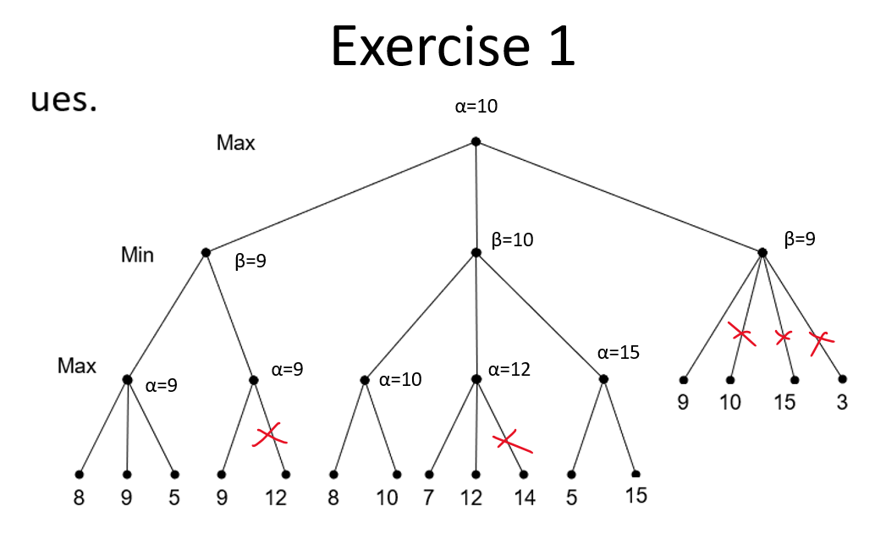

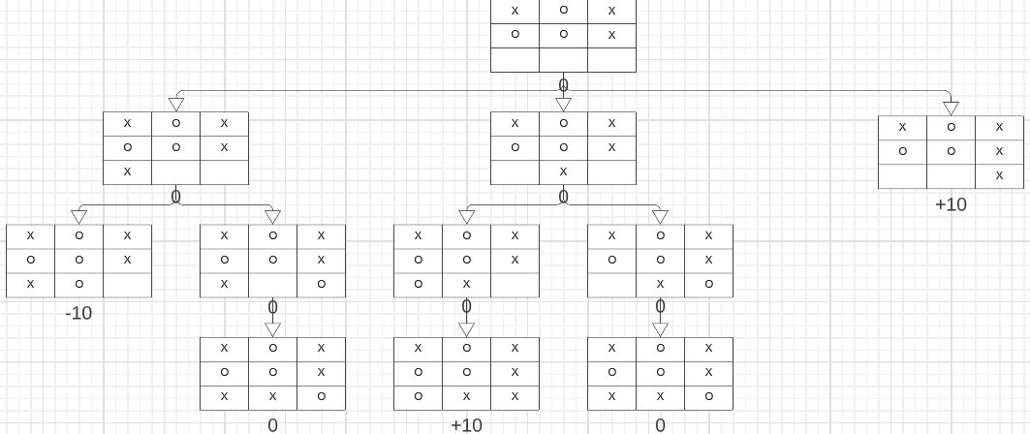

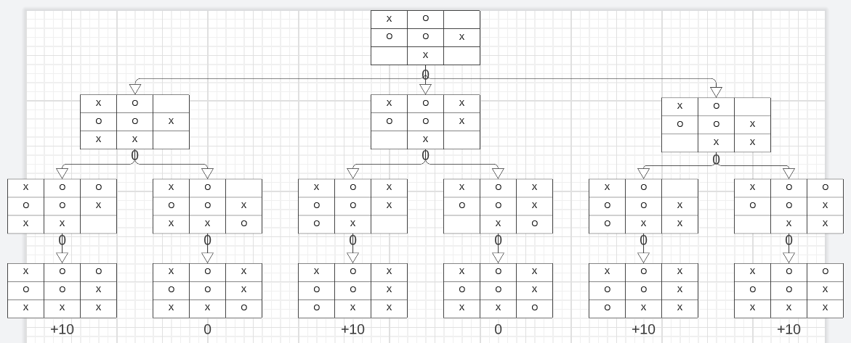

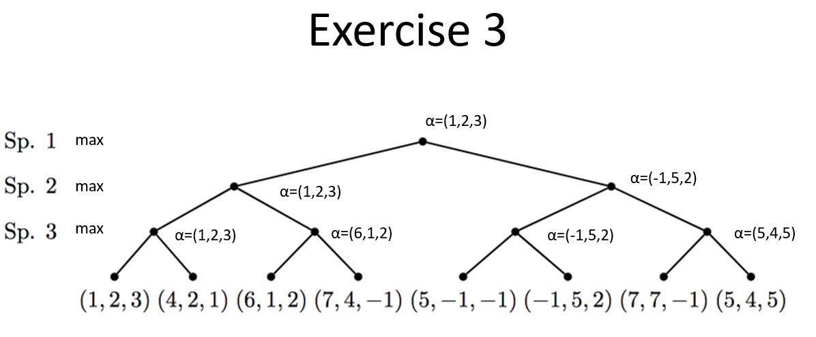

1. EXTRA MILES

For extra miles, I did the “Draw the search tree and perform alpha-beta for the following games:” and I choose tic tac toe.

Assume the initial state is as follows:

**[[_,_,_], [X,O,_], [X,O,O]]**

**Player O’s turn  
If O win, +10**

**If X win, -10**

**Draw, 0**

The search tree after alpha-beta pruning:

The search tree is visualized with html and JavaScript code taken from:

<https://gist.github.com/davidrobles/c4f8a3d6403b48692fa4>

Unfortunately, the code above can only visualize the tree and cannot do the alpha-beta pruning, so I did the pruning manually.

Then, I found a GitHub repository that created a tic tac toe AI using minimax and alpha-beta pruning, the repository link:

<https://github.com/GeorgeSeif/Tic-Tac-Toe-AI.git>

In the repository, there are the code and the pseudocode for the algorithm and the pseudocode is as follow:

Pseudocode explanation: